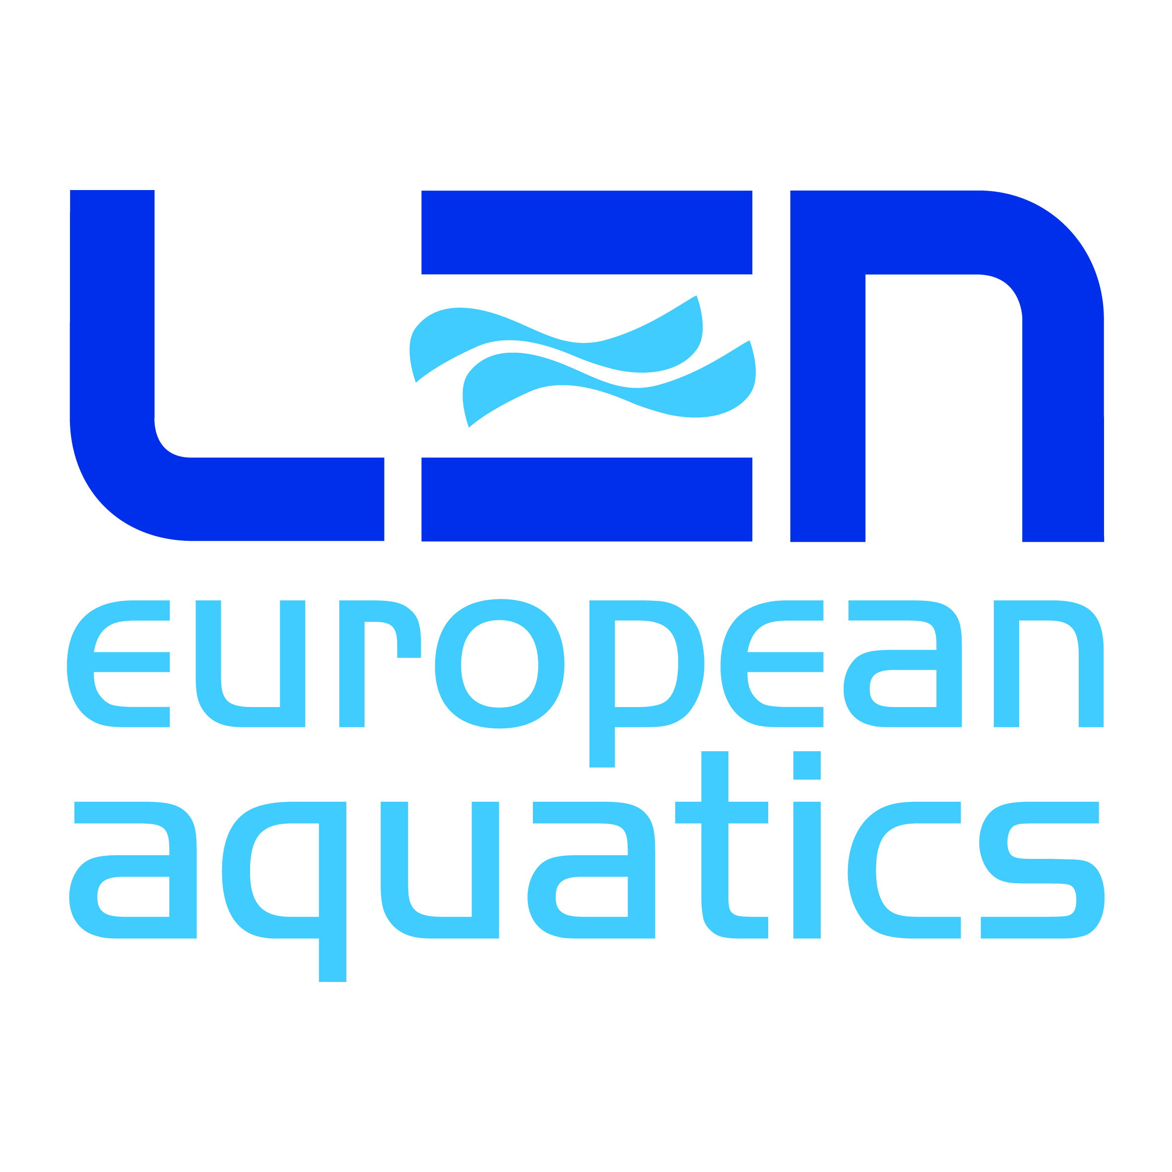

EUROPEAN ARTISTIC “SYNCHRONISED” SWIMMING CHAMPIONS CUP

St. Petersburg (RUS) – 10th – 12th May
Synchronised Swimming

JUDGES NOMINATION FORM

European Artistic “Synchronised” Swimming Champions’ Cup will be held in St. Petersburg (RUS) from 10th to 12th May 2019.
According to Cup-SY 7.1 Each participating Federation is obliged to enter at least one (1) judge from the LEN or FINA list. The Participating Federations may also enter a second judge from the LEN or FINA list. The selected judges must have passed the current FINA School. They are obliged to take part in all officials meeting and must be present to all competition session.
Cup-SY 7.2 Non participating Federations may enter a judge from the current
Officials approved by LEN are on the costs of the nominating Federation.
All judges officiating at LEN events must have completed the current FINA judge’s school and the e-test successfully. The list of nominees will be presented to the LEN TSSC for their final approval. The approved list will be circulated by 19thApril 2019.
Please, note that no shadow panel will be implemented at the above mentioned event.

FEDERATION: | Code __ __ __
ARTISTIC “SYNCHRONISED” SWIMMING  1 or 2 Officials from the FINA or LEN Officials’ list | FINA Judge School  (date & place) | Polo sizes
First name + Last name:
First name + Last name:

__________________________ ______________ Date: ____ / ____ / _______
President /Secretary General Federation Stamp

to be returned to the LEN Office (lenoffice@len.eu) by March 29th, 2019

